Heavy Load Monitoring System

Komal Potdar1, Namrata Gaikwad2, Aditya Kurapati3, Meenakshi Sutar4, Ronak Dabade5, Gaurang Khanderay6 123456 Department Of Computer Engineering Vishwakarma Institute of Technology Pune,Maharashtra, India.

***Abstract* — *This paper focuses on the problem of determining vehicle weights, especially regarding heavy loads in transportation. As a heavy loaded vehicle causes infrastructure damage and poses risk of accident leading to loss of life. The proposed solution integrates Radio-Frequency Identification RFID, load cell and arduino into a system of real time weight monitoring. RFID tags facilitate vehicle recognition while integrated load cells support weight measurement. The load of the vehicle will be compared with its capacity and based on the result, the LED will blink and barricades will open or close. The architecture of the system emphasizes efficiency, accuracy and real-time decision making. The main objective of this work is to check whether the vehicle is overloaded or not.***

***Keywords— (*** *Arduino, Barricade, Capacity, HX711, Load Cell, Overloaded, RFID, Vehicle, Weight* ***)***

# Introduction

On Indian roads, overloaded vehicles are a regrettable but frequent sight. While some city roads are spared, highways are a different story. Truck after truck, carrying more weight than they can hold, drives on congested Indian roads. When compared to roads in developed countries, Indian roads are narrower and poorly maintained. They are designed to last 10–12 years and support an axle load of roughly 8.16 tonnes. The weight increase of even 10 percent above this limit damages the road to the extent that the road's lifespan is reduced by a staggering 35 percent. They have also become among the worst offenders in terms of pollution and unsafe driving. In Fig.1, a vehicle carrying goods in excess of its payload capacity can emit exponentially more toxic gases than one that is not overloaded [1]. Not only that, but they also pose a risk to other drivers. An overloaded vehicle's driver loses control and gets into accidents.



Fig.1. Overloaded Truck

In recent years, work has been done in monitoring, detecting and controlling overload in the vehicles[6]. The proposed heavy load monitoring system integrates RFID technology, load cells, servo motor, LCD display, and Arduino Uno. The RFID identifies the vehicles and their capacity, the Arduino processes the data, the load cells measure weight, and the system uses this information to control an obstacle driven by a servo motor. Access is granted or denied based on a comparison between measured load and RFID-tagged vehicle capacity, with real-time status displayed on an LCD screen This system ensures that load heavy monitoring is smooth and automated and access is controlled.

The solution can help regulate loads at toll gates, ensure fair tolls and prevent road damage. On bridges, the system can monitor loads in real time, providing early warnings of potential structural problems. At CVWS, this technology streamlines traffic and ensures commercial vehicles meet load regulations. Managing heavy loads on construction sites helps keep equipment safe, prevent overloads, facilitate efficient delivery, and enhance both safety and compliance.

# Literature Survey

A comprehensive review of studies in the field of heavy load monitoring systems reveals a multifaceted exploration of technologies and methodologies. A study conducted by PIARC in 2022 underscores the impact of heavy vehicle overloading on road infrastructure, emphasizing the necessity for effective monitoring systems to mitigate adverse effects[2]. Express Roadways' 2022 study highlights safety implications associated with heavy loads on roads, underscoring the role of monitoring systems in preventing accidents and ensuring road safety.

A study in May 2023 investigates The Role of Internet of Things (IoT) in Heavy Load Monitoring, exploring the integration of IoT technologies for improved efficiency and reliability. Universal Smart Cards Inc.'s investigation into the use of Radio-Frequency Identification (RFID) in transportation explores how RFID technology can enhance vehicle identification, forming a basis for efficient heavy load monitoring[3]. Another study from 2022 focuses on the Integration of Load Cells in Transportation Infrastructure, evaluating the feasibility and benefits of incorporating these sensors into roads and bridges for real-time measurement of heavy loads.

The Load Detection and Monitoring System paper from February 2020 introduces the use of weight sensors and Arduino to detect and alarm for overloaded vehicles at toll gates, enhancing safety and road durability[4]. State-of-the-Art Technologies in Weigh-In-Motion Systems (2016) offers insights into advancements in weigh-in-motion technologies, assessing the accuracy and efficiency of load cells and sensors for heavy load monitoring[5]. Two additional studies offer forward-looking perspectives: one identifies emerging trends and potential areas for future research and development in heavy load monitoring systems, while the other explores case studies where monitoring systems have been successfully implemented, providing practical insights into applications and outcomes.

# System Model And Working

The heavy load monitoring system combines RFID technology, load cells, and Arduino to assess real-time vehicle weight. RFID tags identify vehicles, load cells measure weight, and Arduino processes the data. The system compares the actual load with RFID-tagged capacity, triggering actions like LED blinking and barricade control via a servo motor. The LCD display shows real-time status, determining access based on load status.

The block diagram in Fig. 2 illustrates how an RFID reader reads a vehicle's RFID tag on the weighbridge to retrieve vehicle information. The weighbridge is outfitted with a load sensor that is linked to a HX711 amplifier. Following the processing of load sensor and RFID data, the decision logic compares the actual load with the capacity that has been RFID-tagged. The control unit receives the result and controls actions. The control unit ensures an effective and automated heavy load monitoring process with precise decision-making and access control by integrating with an LCD display for real-time status and controlling the barricade system based on decision logic.

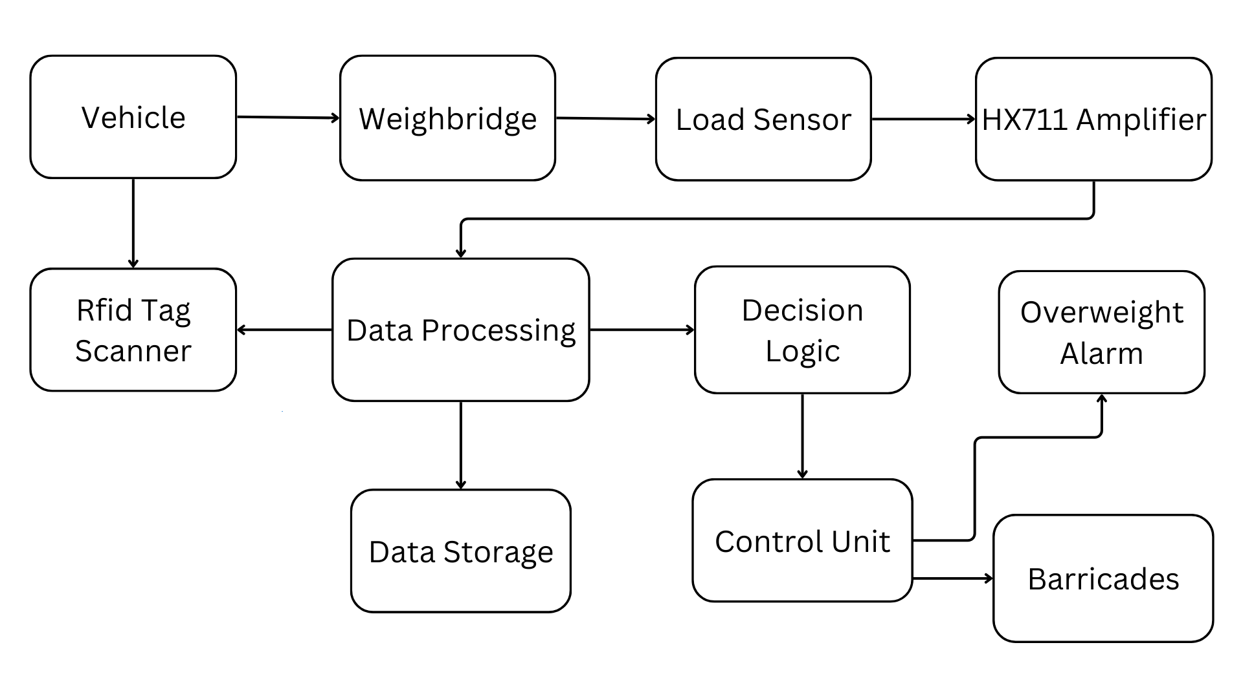

Fig. 2. Block Diagram

The load cell can measure weights of up to 5 kg. As shown in the Fig.3 it is attached to a transducer, the HX711, which transforms weight into an electrical signal. Four wires are usually found in a load cell: signal (+), excitation (-), excitation (+), and signal (-). Excitation wires should be connected to the HX711's E+ and E-pins, and signal wires should be connected to the A- and A+ pins. By connecting the HX711's VCC pin to the 5V pin, GND pin to GND pin, DT (data) pin to D2 pin, and SCK (clock) pin to D3 pin on the Arduino, the HX711 can now communicate with the Arduino Uno. RC522 RFID card reader module is connected to the arduino, which operates at a frequency of 13.56MHz. The servo motor is connected to the arduino which will rotate at an angle of 90 degree to open the barricade and remain at the same position to close the barricade depending on the load. The LCD has four pins GND, VCC, SDA and SCL which are connected to arduino pins GND, 5V, A4 and A5 respectively to display the result.

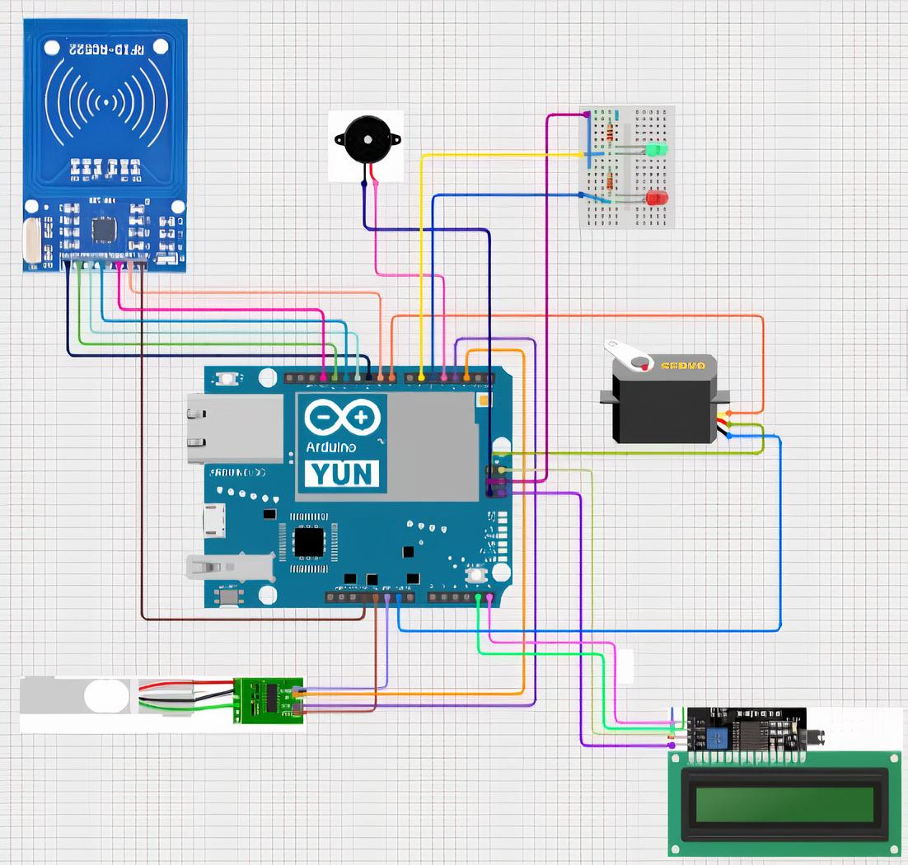

Fig. 3. Circuit Diagram

As shown in the Fig.4 the heavy load monitoring system works in following three modules :

1. Load Detection Module:

Load Cell: When a vehicle comes onto the load cell, the load cell measures the weight of the vehicle. Load cells are transducers that convert force (weight) into an electrical signal. The load cell used in this system is connected to an HX711 amplifier.

HX711 Amplifier: The HX711 amplifier is responsible for amplifying and conditioning the signal from the load cell. It converts the analog signal from the load cell into a digital signal that can be processed by the microcontroller (Arduino).

Arduino Processing: The Arduino microcontroller receives the digital signal from the HX711 amplifier. It processes this information to obtain the actual weight of the vehicle. This weight data is then used for comparison with the vehicle's capacity.

2. RFID Scanning Module:

RC522 RFID Scanner: The RC522 RFID scanner is employed to read the RFID tags attached to vehicles. When a vehicle passes through the scanning area, the RFID scanner captures the unique information stored on the RFID tag.

Vehicle Information Retrieval: The information retrieved from the RFID tag typically includes details such as the vehicle model and its capacity to carry weight. This information is crucial for the subsequent comparison with the actual weight measured by the load detection module.

3. Barricade Control Mechanism:

Weight vs. Capacity Comparison: After obtaining the actual weight of the vehicle from the load detection module and the capacity information from the RFID scanning module, the system compares these values. This step determines whether the vehicle is overloaded or within its permissible limit.

Barricade Action: Based on the result of the comparison, the system triggers the barricade control mechanism. If the vehicle is within its capacity, the barricade opens, allowing the vehicle to proceed. If the vehicle is overloaded, the barricade remains closed, preventing the vehicle from proceeding or signaling a warning.

LCD Display: The system displays the result of the comparison on an LCD screen. This visual feedback informs operators and drivers whether the vehicle is overloaded or compliant with weight regulations.

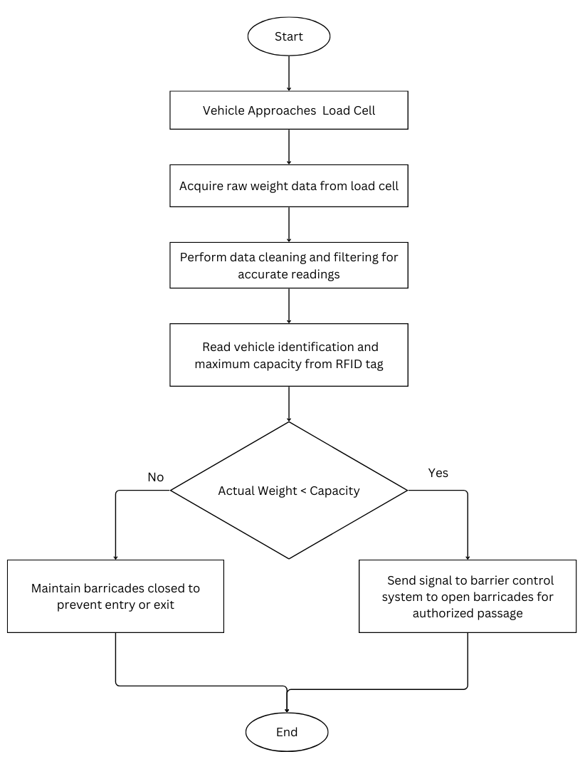

Fig. 4. Flow Chart

# Implementation And Results

Table 1 shows the experimental results of the load cell. The prototype of research uses grams(g) as the unit of measurement, with the integrated load cell having a capacity of 5 kg (5000 grams).

| Number of Experiments | Sensor Readings  (Actual Weight in grams) | Maximum Capacity  (Rfid Tag) | Overload Detection State |
| --- | --- | --- | --- |
| 1 | 580 g | 1500 g | Not Overloaded |
| 2 | 1120 g | 1500 g | Not Overloaded |
| 3 | 2500 g | 2000 g | Overloaded |
| 4 | 2580 g | 2000 g | Overloaded |

Table 1. Results

When the actual weights in the first two experiments were less than the 1500g RFID-tagged capacity, the system correctly identified them as "Not Overloaded." On the other hand, the system correctly detected an "Overloaded" state in experiments 3 and 4, where the actual weights exceeded the 2000g RFID-tagged capacity. The results obtained demonstrate how well load cells work in real-time weight monitoring, which is essential for keeping vehicles under weight limits.

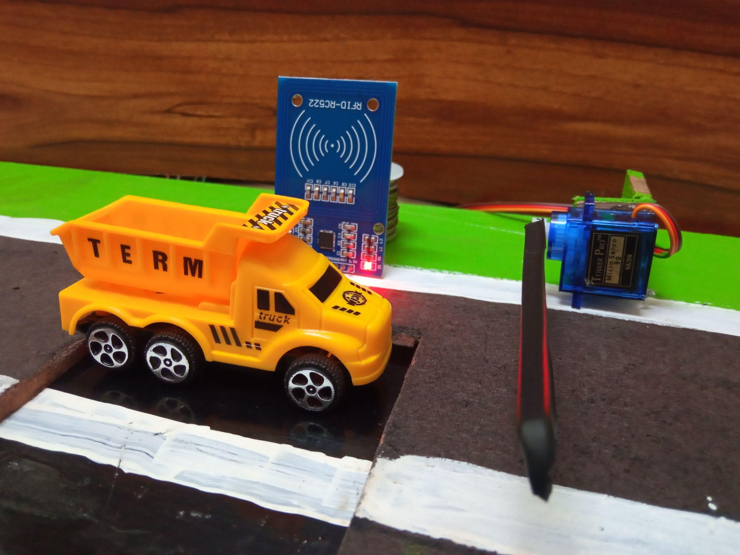

Fig. 5. Prototype of heavy load monitoring system

# Future Scope

In the future, the heavy load monitoring system's scope can be enriched by the integration of Weigh-in-Motion (WIM) systems, employing an array of sensors to measure various vehicle features during motion. The upcoming focus extends beyond weight analysis to encompass a machine learning framework, which evaluates vehicle equipment health. This adaptive system, learning from real-time and historical data, optimizes load distribution to minimize accidents and reduce mechanical wear. Additionally, the future vision includes incorporating weight-based tolling mechanisms to encourage compliance and generate revenue for infrastructure maintenance. Acknowledging the rising connectivity of devices, cybersecurity measures will be paramount. Robust protocols can be implemented to prevent unauthorized access and potential disruptions, ensuring the reliability of heavy load detection systems in an interconnected landscape.

# Conclusion

In conclusion, the integrated heavy load monitoring system, utilizing RFID, load cells, a servo motor, and Arduino Uno, efficiently manages access based on designated vehicle capacities. This streamlined architecture ensures weight measurement and controlled barricade operations, enhancing security and operational efficiency in transportation scenarios. The system's simplicity and effectiveness underscore it as a practical solution for real-time heavy load monitoring and access control.

##### References

1. Rupal Shah, Yogesh Sharma , Binil Mathew, “Review Paper on Overloading Effect”, International Journal of Advanced Scientific Research and Management, Vol. 1 Issue 4, April 2016.
2. Simula Fontu, Lain Knight, Bernard Jacob, “Overweight Vehicle: Impact on Road Infrastructure and Safety”. PIARC, 2022.
3. Universal Smart Cards Inc.,“RFID Technology - What are its uses in the transportation industry?” Available : <https://www.usmartcards.com/news-blog/rfid-technology-what-are-its-uses-in-the-transportation-industry>
4. B.Vishnupriya, M.Susmitha, “Load Detection And Monitoring System”, International Journal of Scientific & Technology Research Volume 9, Issue 02, February 2020.
5. Yang Yu, CS Cai and Lu Den, “State-of-the-art review on bridge weigh-in-motion technology”, Volume 19, Issue 9, 2016. Available: <https://doi.org/10.1177/1369433216655922>
6. Anusha Gaira, Alima Praveen, Drishti Dabral, “Vehicle Overloading: A Review”, International Journal for Research in Applied Science and Engineering Technology (IJRASET) ISSN: 2321-9653.Vol. 8 Issue 07, July-2020.
7. M Z Rohim et al 2021, “Design of overloading detection systems on vehicles using arduino”, 2021.
8. Jaya Kumar R K, Navadeep N, “Overload Detection and Load Tracking System”, 2019 JETIR April 2019, Volume 6, Issue 4.
9. Fatah Chetouane, “An Overview On RFID Technology Instruction And Application”, Volume 48, Issue 3, 2015.
10. Sravanthi Alamandla, Kishore Putha and Sai Prasad R L N ,”FBG sensing system to study the Bridge weigh-in-motion for measuring the vehicle parameters”(2018).
11. K.Balamurugan,Dr.R.Mahalakshmi, Dr.S.Elangovan and R.Pavithra “Automatic check-post and fast track toll system”(2017).
12. Mrunal Pimpalkar and Neha Bhoyar , “Overload Detection System Using Strain Gauge On Load Cell”, International Research Journal of Modernization in Engineering Technology and Science Volume 4, Issue 05, May 2022. Available at <https://www.irjmets.com/uploadedfiles/paper/issue_5_may_2022/23909/final/fin_irjmets1653483955.pdf>
13. Javad Sardroud, “Influence of RFID technology on automated management of construction materials and components”, [Volume 19, Issue 3](https://www.sciencedirect.com/journal/scientia-iranica/vol/19/issue/3), June 2012, Pages 381-392. Available: <https://doi.org/10.1016/j.scient.2012.02.023>
14. Mohamed R K , Ahmad S A, Hideo Y, Airul S A, Rahizar R, Degree of Vehicle Overloading and its Implication on Road Safety in Developing Countries. IISTE (Civil and Environmental Research) , Vol 3(12),20-31,(2013).
15. H. D. Kattimani, Meghana N R, Nagashree B, Sahana Munegowda , Vijayalakshmi S, “Vehicular Overload Detection and Protection”. International Journal of Latest Research in Engineering and Technology (IJLRET) ISSN: 2454- 5031.PP.119-122 National Conference on Control, Communication and Power Systems-2017.
16. Ms. Renju K, Ms. Perpetua F Noronha, “A Survey on Detecting Overloaded Vehicles in Video Surveillance Systems”. International Journal of Engineering Research & Technology (IJERT) ISSN: 2278-0181.Vol. 4 Issue 02, February-2015.
17. Ebenezer Narh Odonkor, “Design and Construction of Vehicle Loading Monitoring System Using Load Sensor and GSM”, International Journal of Engineering Research & Technology (IJERT) ISSN: 2278-0181.Vol. 10 No.1, Issue 02, January-2020.
18. P. Johannesson, M. Speckert, "Guide to Load Analysis for Durability in Vehicle Engineering", International Journal of Latest Research in Engineering and Technology (IJLRET), Vol. 33 No. 10, pp. 886-917, 2013. Available at : <https://www.academia.edu/66705669/Guide_to_Load_Analysis_for_Durability_in_Vehicle_Engineering>
19. Andrew Jason Tickle, Proof-of-Concept Development for a Weight-to-Speed System on Heavy Goods Vehicles, 2012.
20. Farhad Ismail, Development of a Model for Electronic Toll Collection System, IEE Sensors Applications Symposium (SAS), 2015.
21. Mehran Safdar, A Mobile Vehicle Weight Sensor and its Application in Transportation, Trends cogn.sci, 4(3), 2000, 91-99.
22. Nemoto T, Measurement by load cells of impact force which a human body receives by external force, Journal of Software Engineering, 2009.